KESWICK AND INTWOOD PARISH COUNCIL.

LOCAL GOVERNMENT ACT, 1972 (Section 87(2))
CASUAL VACANCY IN THE OFFICE OF COUNCILLOR

PUBLIC NOTICE IS HEREBY GIVEN that a casual vacancy has occurred in the Office of Councillor for the above Parish by reason of the resignation of Kimberley Diehl.

Rule 5(2) of The Local Elections (Parishes and Communities) (England and Wales) Rules, 2006 now applies.

An election to fill the vacancy will be held, if within 14 days (not counting Saturdays, Sundays and Bank Holidays) from the date mentioned below for 10 electors for the parish give notice in writing requesting an election to the Returning Officer.

If a request to hold an election is not received, the Parish Council must, as soon as practicable after the expiry of the fourteen day period, co-opt a person to fill the vacancy.

For further guidance please telephone (01508) 533795 or e-mail elections@s-norfolk.gov.uk

The name and address of the Deputy Returning Officer is:

Julia Tovee-Galey
Electoral Services Team
South Norfolk Council
Swan Lane
Long Stratton
Norwich
NR15 2XE
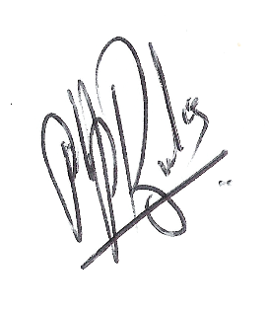 Phillip Brooks. 7 Lindford Drive, Eaton, Norwich NR4 6LT.
Clerk to Keswick and Intwood Parish Council.

Date: 2nd October 2019.

