CONFIRMATION OF THE DATES OF THE PERIOD FOR THE EXERCISE OF PUBLIC RIGHTS

Keswick and Intwood Parish Council

On behalf of the smaller authority, I confirm that the dates set for the period for the exercise of public rights are as follows:

Commencing on 4th June 2018

and ending on 13th July 2018

signed: 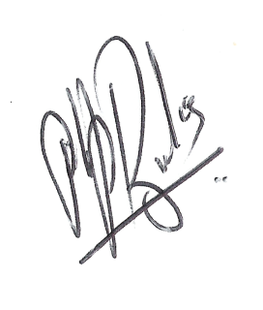

Role: Clerk and Responsible Financial Officer

